5. Seeding and Nurturing Game Making Communities to Facilitate Learner Agency
- Research Questions - June 2023
- Introduction
- Exploring the impact of a drama processes
  - Vignette 4.1.a - Introducing a drama process
  - Description of Vignette 4.1.a
  - Vignette 4.1.b - Session reflections and secret missions
  - Description of Vignette 4.1.b
  - Reflecting in role
  - Observations on written interactions with the alien in the drama
    - Exploring documentation and accessing technical help within the drama frame
    - Playful dialogue with the aliens unrelated to game making
  - Use of side missions to encourage varied creative practices
  - Concluding remarks on process drama
- The impact of the core tools of code playgrounds and templated game
  - Code playground
  - Impact of the half-baked game template
    - Observations on design behaviours encouraged through use of game template
- Emerging processes and use of tools
  - Emerging use of narratives and graphics which drawing on home funds of knowledge
    - Summary: Home Funds and RQs
  - Playtesting
  - Flexible divisions of labour
- Discussion
  - Flexible design practices
    - The potential of emergent “non-productive” activities
  - Supporting Digital Jamming
  - Discussion on authenticity
  - Agency and emerging spaces for community activity
    - Positive affective space within a drama process
    - Extending the metaphor - anchoring in sheltered harbours
    - Implications in conceptualisations of forms of agency
- Conclusion Nurturing agency by creating space for emergent practices

Research Questions - June 2023
- What pedagogical tools and processes are available to support novices to overcome barriers to game coding and design?
- How can learners build agency in an evolving community of game makers?
- How can game design patterns support the development of coding practices with novices?

10,400 words (without references etc)

Introduction
This chapter is concerned with examining the impact on participants of the learning design explored in the last chapter.

Exploring the impact of a drama processes
The introduction of a drama process was introduced in response to the barriers to participation caused by not identifying with the culture of coding or gaming. This section describes the addition to the intervention and explores its value as a pedagogical tool to seed game coding practices and to develop learner agency.

Vignette 4.1.a - Introducing a drama process
The participants have entered the room and chosen a laptop to work on. Some of the children play web-based games or review the games that they have made previously. The session progresses with a warm-up game which includes many false starts, changes of rules, development of tactics, appeals to be serious, full throated laughter and many restarts and which ends in good hearted failure. The transcript below picks up at this point.
Mick: Ok. So I’ve got a surprise. I don’t know if you know but as part of our Home Ed club we did a page of different games. So it’s on glitch.com and it’s called Glitch Game Club and it’s on there, there’s one for Home Ed Winter 2019 and here are all the games that we made. We made a lot of games. 15 games. This has not gone unnoticed because I got a message through this account. This is kind of a story now. We are entering a story. You have to use your imagination. We got a message and it was an audio message. If you guys take your fingers off your keyboards and have a listen to this audio message which is quite unusual as I don’t think it was from anyone on … this … Earth.
Greetings Earthlings, we have an important message for the Glitch Game Makers.
We are the Weean. You would call us an alien lifeforce. We like to think of ourselves as friendly space cousins.
We can see your Internet from space. We are contacting you because we know you are making games on the Internet.
We are on our way to the Planet Earth, and we have an important mission for you. We are an Intergalactic Rescue team. We know you have problems on your planet. We can help.
But we need to find out one thing first. Are you worth it? After we are gone will you also be able to help yourselves? Or are you already doomed to make the same mistakes again?
You must pass this challenge. Make some games showing problems you have on earth. In the games also include ideas for how to solve them.

We have some guidelines:

• Make a game about a big or small problem to solve. If you can let us play it each week as you go along.
• Give us an update each week by recording a group update.
• Show you can work on your own but also work as part of a team.
• We will also send you text messages with some mini-missions sometimes. Be sure to tell us how you do.

Please now get started and come up with a new game about solving a problem on Earth.
Mick: I couldn’t understand all of it but I tried to write it down as best as I can. So from what I’ve worked out they’ve looked at our games and they’ve come up with a challenge for us. They are coming to Earth so they need to find out if we are worth saving. And the way that they are going to decide is by playing the games that we come up with. And they are going to set us little challenges. So. yeah, that’s the story. (with heavy irony) I’m pretty sure it’s true. (Mick and others laugh).
Mick: So all they’re asking us to do is to come up with a game. We’ve got four sessions. They want a new game because they’ve already played our old games. It’s got to be something about the problems of the world. I’ve got a lot of problems. It could be big problem or a small problem. It could be about your problems. But also ideas on how to solve them.
And yeah. That we can work by ourselves but also work as part of a team. So we’ve got to give them a report by the end of each session as well. That’s our mission.

Description of Vignette 4.1.a
The process of introducing a scenario for participant to respond to is common in project based learning in this vignette. Here it is extended using a dramatic element in line with Heathcote on Mantle of the Expert (MoE) and other process drama techniques (explored in Lit Review). In this section, I describe the vignette using concepts from MoE. Further analysis follows in a later section.
The following tenets of MoE from Aiken’s summary (2013) apply. Aitken’s and Heathcote’s terms follow in italics. Within a fictional context a responsible team is contracted into a commission by a client. The facilitator frames curriculum elements as productive tasks and plans for tensions to arise involving: authentic contexts, messiness of learning, maintaining learner interest and resilience to overcome the grappling and struggling involved. The following sections explore some of these key concepts via the example in vignette.
Contracting into drama
As a facilitator, I indicate that we are entering a dramatic process and attempt to draw everyone along with me using the following sentence “This is kind of a story now. We are entering a story. You have to use your imagination”. This serves to start the process of contracting in a drama. As a way to introduce the imagined audience, I reference that the games are online and have been noticed by aliens. The use of heavy irony in my voice when concluding the scenario, “I’m pretty sure it’s true” and the resulting laughter form an informal collusion that we are playing along with this fiction. The collusion is noted by both parents and children in recorded exchanges. For example, after engaging with a code example provided by myself in the role of the aliens, one pair make the following comment.
Parent: Look, this is what Mick’s showed, what Mick’s has done.
Child: The Weean have done!
Parent: The Weean, sorry yes.
Facilitator activities in role
My role is a link between the participant and the fictional commissioners of the games. The transcript above (a fuller version is in appendix 4.x) captures a rare example of myself extended facilitator input as instruction. As a practitioner teaching technology, I try to limit teacher talk and being overly directive to prevent learner disengagement. COMPLETE.
Balancing learner choice with over-ambition is a tension explored in the previous chapter. The drama narrative helped resolve some of this personal tension by allowing me to outline boundaries and be directive using the dramatic commission as a foil to help avoid the encounter feeling personally combative or controlling [heathcote_drama_1985].
Learner activities in role
Beyond the wider fictional frame of the making activity, learners were also sometimes asked to undertake some activities in role, in particular reflection in role. This and other examples are explored via the second vignette.

Vignette 4.1.b - Session reflections and secret missions
This second extract comes from the following session in phase four. In three of the four sessions the last 10 minutes of each session involved giving a progress update to the aliens.
Mick: Ok are you guys ready to share back if you could come to this side of the room we are going to get Mark and Edward to share back first. Everyone can share back using this computer that the Weean are watching if that’s alright. organiser
Mark: All we’ve done today is just get a background in and then we were just working on the one that the Weean had sent us about dropping the coins in. Now that the Weean have sent us the code we need for basically dropping stuff.
Mark: The idea is planting trees. about dropping seeds. So we want to drop those and have some enemies that are tweening randomly around and also taking them away. The idea is to have a timer to drop a certain amount in a certain time frame or you can’t go through to the next level. And the next level would be you go around and water all the trees. And the third one is you have to look after them all making sure they are not getting chopped down again by that tweening enemy. So we’ve got the concept and everything now and we’ve got the code So we should be able to make a bit of a jump forward now this week. It doesn’t look like we’ve got any where but we have. (Mark laughs and others follow). So we’ve got the the background in and we know what we need to do about scrolling as well because we want to scroll across.
Mick: That’s great. Is there anything that you think you definitely want to be able to do for next time that you might want help with?
Mark: Oh yeah. We’ll we’ve got a bit of space where we can work on it before we next come in so we’d like to ask the Weean some more questions. Is that the best way to do it?
Mick: Yeah for sure and I can see that you guys have been talking to the Weean, Here this project here in your home page called Talking to the Weean allows you to talk to the Weean. So you can go in there, click on Edit Project and if you click on this bit here that says WEEAN and then Markdown you can actually just ask questions in here.
(Mick reads out the following extract the organiser screen containing a text chat with the fictional alien audience)
Ed: Weean what’s it like up there?
Weean: It’s cold and very big but quite tranquil.
Ed: What is your name?
Weean: We are are the Weean we have no name, we are all the same.
Ed: That must be hard at xmas. (Mark and others laugh and smile.)
Weean: It is. It sure is.
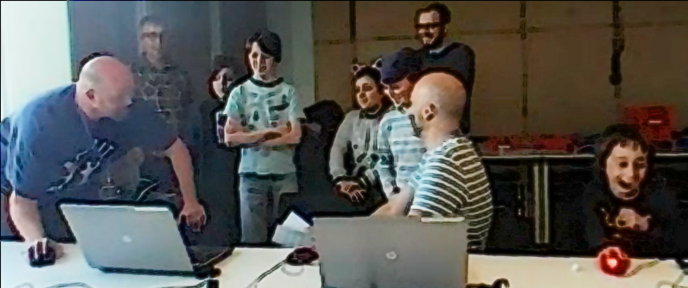
Mark: That’s tickled me that.
Mick: So there you go. You can have a conversation there with the Weean in there using mark up code you can copy what’s there. Nadine can you talk through what you have added to your game? Is yours called “No Toby Allowed” now. (Laughs from all)
Nadine: I’ve not really done much today as I was busy doing stuff with Toby’s
Dan: We noticed.
Nadine: We’ll I’ve changed the platform a bit
Molly : You had a secret mission though didn’t you
Nadine: Oh my secret mission was to change someone’s game, their character or something and see if they noticed. And I think they did notice.
Dan: We did. We did notice.
Molly : You couldn’t not notice.
Mick: It feels like you took the spirit of the mischievous thing and just turned up the volume. (All laugh.)
Molly: Sprite!
Mark: We also had a secret mission.
Mick: What was that?
Mark: Ours was to change the sound on somebodies game.
Nadine: Oh was it?
Mark: Did you notice?
Molly: Did you notice?
Nadine: No (laughing) (Incomprehensible many people talking or laughing at same time)
Mark: Play it now!
Richie: You definitely noticed. (Points to Mark and Ed) You definitely noticed my bit.
(Nadine goes to the keyboard and starts to play her game)
Nadine: I can’t hear anything different (Everyone laughs)
Mark: I thought you were going to go- Aaahgh! But you didn’t say anything.
Mick: So that’s interesting. some people notice some people didn’t.

Description of Vignette 4.1.b
In this extract participants are invited to take turns showing their game, recapping their progress and outlining next steps to the alien observers. I play the role as a liaison facilitating the process for the fictional, remote audience. I also draw attention to the secret missions that had been distributed to participants (along with social missions - both explore later in this chapter).

Reflecting in role
It doesn’t look like we’ve got anywhere but we have!
While drama scenarios can aid reflection both in or out of drama, O’Neill and Lambert outline the value of in-drama reflection, noting it is “likely to be more powerful than end-of-session discussion, since it allows individual and group insight to be articulated as part of the context” (1982:144). In line with this intervention, they propose one way of achieving in-role reflection is to introduce an additional character that acts as an external audience. In this intervention however, main activities happen only weakly in role, whereas the end reflection highlights the fictional frame of the making more strongly.
In my journal notes for phases prior to using the drama process, I documented that the occasional end of session debriefs as go-rounds had limited success in terms of amount and quality of participation compared to these sessions. The video and audio recordings document rich feedback from individuals and pair teams, near complete participation and productive elements of interaction as the feedback progresses.
In previous iterations, my omission of end-reflection in sessions stemmed from a lack of time in sessions and reluctance to shift learners away from making activities to reflective activities. I found the need to maintain the drama narrative served as a high motivation factor to complete reflection activities.
To begin the reflection session I asked participants to gather around a particular computer which the aliens are monitoring which helped moving participants closer to each other and stop their coding activity. It is of value to review the grouping of participants in the still image in the vignette above in Fig 5.x. The simple clustering of partfanicipants so they were side by side and talking to a disembodied audience via a computer seemed to make the feedback process less daunting for students. One of the younger participants Richie is participating on the margins but clearly following proceedings as his facial reactions to ongoing contents of feedback. He later participates more actively when reflecting on his process than he had done in previous sessions. Even participants that were initially reluctant to share back and had never shared back publicly before in sessions, chipped in after other family members had started the process for them.
Using the terms of student agency explored in the literature review, here we can see the use of the drama narrative used as a second stimulus both by facilitator to help convene learners and to help them participate in reflection, and project sharing (Sannino, 2015).

Observations on written interactions with the alien in the drama

Exploring documentation and accessing technical help within the drama frame
In the first phase of the project, I had promoted the use of a mailing list to ask technical and code questions of the wider group. This surfaced a conflict where parents were reluctant to bother other participants with such issues.
To address this, as part of the drama process, I encouraged participants to communicate with the aliens to ask for help. To do this in a way that encouraged other participants to join in, I created a project in the shared coding project area with a webpage that could be edited and viewed by participants. When in the vignette 4.1.b Mark asks “We’d like to ask the Weean some more questions (to overcome coding blockages), is that the best way to do it?”, he is referring to this project webpage. To seed this process, I had entered a question sent by Mark and Ed via email into the page, and written a response on behalf of the aliens.
Dan and Toby also received help from the aliens to implement a pattern of creating random movement in their pac-man clone game. For this pair, the process of reading a code suggestion from the aliens gave the parent opportunity to deconstruct the code in detail to explore coding concepts. In later discussion, Dan used the fiction of the alien to playfully chastise me for using code syntax which was harder for novices to read.
"Mick, do you think the aliens would mind if we get rid of the switch statement and replace it with some if-thens? They're just showing off these aliens aren't they?"
Here the text dialogue with the aliens is used as a mediating artefact first by the facilitator to share help in-role, and then by a parent to suggest a modification to the code syntax used and indicating a more general tactic of using readable code structures in novices.
Thus, in summary, the process of writing down a text request in-role potentially addresses the (previously-explored) barriers to asking for help by de-personalising the process. It also encourages the adoption of professional practice of asking a written question to overcome a coding problem and thus builds experience of using technical terms. While this aspect of the drama process was introduced by the facilitator, in alignment with the understanding of Sannino’s concepts of transformative agency through double stimulation (TADS), participants transform the function of the alien conversation to their own purposes. This theme is developed in the next section.

Playful dialogue with the aliens unrelated to game making
The process of asking the aliens for technical help within a code project sparked a playful process of informal chatting with the aliens. During in our end of session reflection above, I noted the following ad-hoc encounter that a child initiated on the interactive page while his father was taking a break from coding.
Ed: hi WEEAN what is it like up there :)
Weean: It is cold and very big but quite tranquil too. all the same.
Ed: What is your name?
Weean: We are are the Weean we have no name, we are all the same.
Ed: That must be hard at xmas
Weean: It is. It sure is.
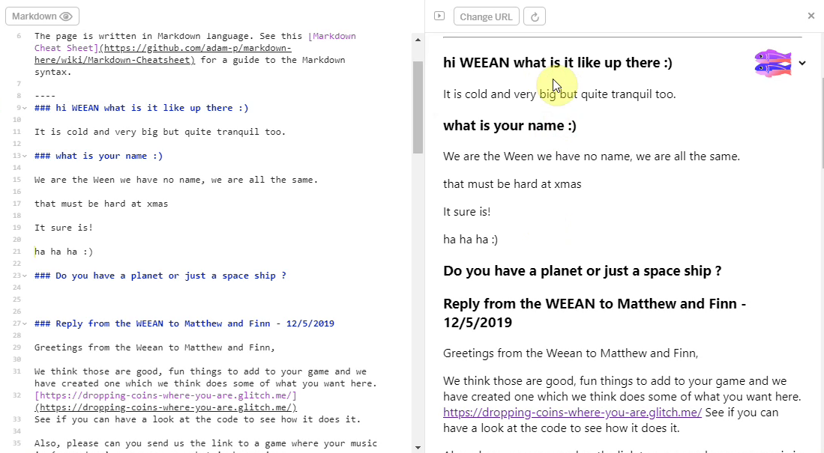
alien feedback
Inspired by the positive reaction of participants to this playful engagement with the fictional audience, I asked a student helper to participate remotely to play the part of the alien. The student then gave feedback via live text interaction to participants in the final session. The process started with supportive and celebratory messages posted from the alien. The impact was significant with the young people with 5 out of 7 of them engaging by writing messages and all mentioning the interactions verbally during the session.
The live chat began to fulfill a function of building insider rapport, creating a fun atmosphere, celebrating the completion of games in the absence of a public showcase, and signposting the achievements of other participants. For some pairs, while the child interacted in the live chat, parents performed final tweaks to code projects and challenges. Two parents in particular worked hard debugging more complex elements of the game with facilitators and peers. Other parents engaged with the chat and encouraged their children to get feedback from the aliens about their game in particular.
The start of process began when Ed in a moment of free time expanded the use of space initially imagined to address technical needs by initiating a playful interaction which, while in the motivation to support different learner identities, was a novel, volitional action in this context. It is helpful to expore this interaction using AT and TADS terminology. Ed is in conflict, not able or wanting to engage in his existing creative activities while his father has a social break. Using the secondary stimulus of a text chat with fictional aliens, he writes a playful personal question to the aliens as an expression of volitional action to play, casts out an experimental kedging anchor. By co-incidence, I was on a different computer, saw this question, and was able to respond in real time. Thus, by getting a response, Ed’s kedging anchor caught onto an anchor point and Ed was able to resolve this conflict of inactivity and in doing so both amuse himself and other other with humorous self-expression, and open-up a novel, child-centred activity for the whole group which could also address potential issues of alienation from the culture of serious coding expressed by other participants.

Use of side missions to encourage varied creative practices
In addition to the main mission to make a game to entertain and inform visiting aliens, extra social and secret missions were delivered within the frame of a drama process, with an explicit aim to encourage community-focused patterns of behaviour which had emerged in previous iterations of game making. These include social aspect of playtesting and playful interactions, explored in later section in this chapter. I had identified these behaviours as potentially helpful in maintaining the positive affect and identification with the on-going group process of game making.
A table of both social and public missions follows. These mission were printed out on cards and one of each type was given to the participants in the first half of the first two sessions.
Your Alien Mission (social) | Your Secret Alien Mission:
Find out the names of 3 games that are being made. | Change the variables at the start of someone else’s game to make it play in a funny way.
Make a list of characters in two other games being made. | Change of the images in someone else’s project to a totally different image and see if they notice.
Find out the favourite computer games of 4 people. | Change the level design of the first level of someone else’s project to make it impossible but try to change as little as possible to do that.
Find out who plays the most computer games per week in your group. | Change of the images in someone else’s project to a very similar but slightly different version and see if they notice.
Find out what other people are planning. Give some friendly feedback to one other person / group. Why don’t you try… | Add a rude sound to someone else’s project.
Ask 2 different groups if they have thought about what sounds they are going to put in their game. | Swap over some sounds in someone else’s project and see if they notice.
Find out from three groups if they are going to try any totally new ideas. | Delete all of the code of someone else as they are editing it and see how they react. Then help them get it back using the Rewind function.

In the transcript above of vignette 4.1.b we see that in the end-of-session reporting back participants engage in a lively discussion about the secret missions they had been given. Encouraged by her mother Molly, Nadine shares that she has been highly engaged in a disruptive secret mission. Dan and Toby express playful frustration. Mark and Ed contribute by sharing their more subtle disruption and Richie is keen to have his rude noise mission noticed and commented on. Some public missions had a noticeable impact in this session particularly in stimulating a discussion among parents around which arcade games they played as youths.
These sanctioned non-design activities, designed to reduce participant stress, and to encourage the exploration of the games of others, are taken up enthusiastically by many of the community. In analysis of one key sessions involving missions from which the transcript was taken. Out of 10 participants, 8 visibly engaged with the secret missions during the session.
The process was not without friction. After initially engaging with the process of secret games, Toby and Dave, who were later working on a tricky coding process, expressed frustration at interference. Thus, while promising, limits to this process should be evaluated to avoid overly disruptive behaviour which create barriers to progress. For example, time limits could be in place.
The positive reaction of young people to the drama process was also picked up in interview data.
Mark: Tell us about the Weean?
Ed: er.
Mark: What did you like about the Weean?
Ed: Just very silly and I don't know. They answered your questions.
Mark: Was it, because there was a sense of play, a bit of fun and a bit of anarchy.
Ed: Yeah.
Mark: What else can you tell us about the Weean?
Ed: er.
Mark: There was the little sabotage things you had to do as well.
Ed: Yeah
Mark: So you liked those games where you had to kind of hack somebody else?
Ed: Yeah
...
Mark: The Weean thing was, I think, a massive hit for everybody because it just brought sense of play and fun. And it took attention away from it being overtly technical. Brought a personal element in and obviously that anarchy. Kids love the absurd.
There is more evidence of the impact of the drama process in the vignette above. In the end of session reflection, Richie occupies a peripheral position and continues to interact with his laptop. However, he reacts positively when Ed’s questions to the Weean are read out. He later adds to the discussion when it turns to the sabotage based missions set in the drama process. It is probably that the ability to represent his irreverent approach helped his participation in the more formal, collaborative reflection and feedback activity in a way that had not happened in previous sessions.
Side missions or side quests are also used in open world games in part to appeal to different kinds of players and are often modelled on Bartle’s taxonomy of game player types (Bartle, n.d.). In this phase, parents Molly and Mark both used the prompts of the social missions to take a break from their creative work using the software toolset to talk to other parents and children. This supported and encouraged behaviours that I had observed in the previous stage where they had been energised by breaks for coding and interactions with others. This activity helps address one of the key barriers to taking part in a coding community: that of alienation from the culture of hardcore coding.
Mark: Right we’ve got a background in. Do you. Do you want to reply to the Weean.
Ed: Yes. (Ed starts to type very slowly)
Mark: (after some time) While you do that I’m going to go do my mission.
Ed: What's your mission?
Mark: To find out about other people's favourite games.
Ed: Alright.
While the some of the secret missions encouraged forms of disruptive play, griefing of playing against the game (Bakioglu, 2008; Bartle, n.d.). While this increases engagement for some learners, the process also suffered the danger that participants transgress levels of cheekiness and play which explores boundaries, to more disruptive ones. In this context this involved frustration and wasted time for other users. The vignette above shows a chance for the parent to express his frustration at the process in a playful way.
The use of missions introduced by facilitator are taken up voluntarily by participants and work to address conflicts caused by identity clashes by recognising and encouraging diverse making approaches and styles of community participation. A BIT MORE ON AGENCY?

Concluding remarks on process drama
This section has explored the use of the possibilities of a drama process to support both the learner expression of agency and as a pedagogical process for facilitators to militate probable conflicts and obstacles for learners in the creative process. The mission-based interventions began as naturally occurring expression of learner agency which became incorporated into the drama process. The next section examines the affordances and impact of the coding environment and starting game template, which in a similar way, evolved in response to participant use of earlier iterations of the toolset. Conversely, examples of more unguided practices and use of tools which served to increase the scope of agency are explored in the final section of this chapter.

The impact of the core tools of code playgrounds and templated game
The last chapter outlined the design characteristics of the coding tools in a face-to-face learning environment, namely: an incomplete 2D platformer; pixel graphics; with graphical scaffolding for text-based code; and deliberately incomplete thus inviting improvement. In this section, I draw on my journal notes and past experience and observations from interpretation of video data to share observations on the use of these tools.

Code playground
My motivation for choice of code language (Javascript, Phaser) was driven by desire to be authentic and facilitate an extensible environment. The use of glitch.com as a code playground significantly reduced technical barriers for students related to this choice. In terms of first impressions, learners first experience was the process of playing a game in a webpage and controlling the character using the computer’s arrow/ cursor keys which for many was a familiar process.
In terms of technical complexity, using a code playground removed the process of setting up a server for web development, and the delay and complexity of transferring files to the server. While the code project consisted of several files of javascript, HTML and CSS, learners were shielded from the complexity of how they were interlinked. In the video data analysed, there were practically no extended blockages to undertaking work related to the use of this environment. While this study does not attempt to quantify this factor, the experience compares very favourably to my experiences of using and teaching coding environments.
There were some issues of access for some participants who did not remember or recall log in details or their project name. These issues were mitigated through the use of a log in details shared between participants. When users struggled to log in or to find the games or assets that they had created earlier they sought and received help from family members or other peers. Direct help from facilitators was rarely required. In the glitch environment code errors were highlighted in with red dot in the interface which gave a quick visual indication of where the error occurred, when the user hovered over gave an error message as a pop up, which while limited and sometimes misleading, gave participants immediate feedback on syntax errors. In analysis of video data, I observed learners reacting to this feedback and either reversing errors such as deleting commas, semi-colons and quotations marks. When participants were coding as a pair, the parent would often notice and point out the red dot, thus preventing further errors. The next chapter explores different types of errors and participant responses to them.
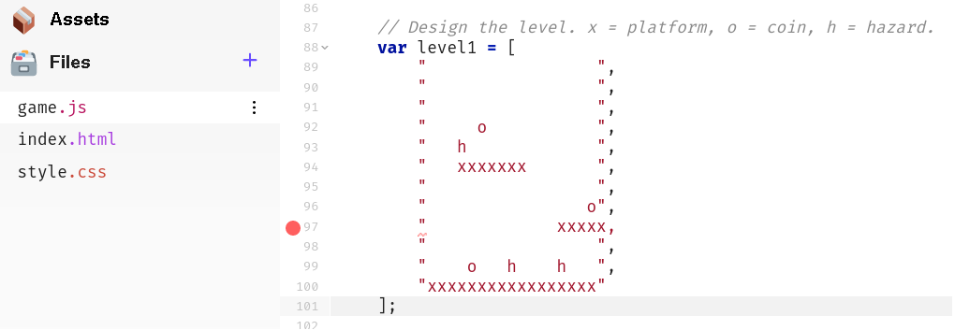

Impact of the half-baked game template
As explored in the last chapter, participants starting with an incomplete game template to scaffold the initial creative and coding process.
Brief help was available via in-line text code comments allowing for self-directed or previously proficient learners to progress with minimal support. In addition, supporting ‘quick start’ cards (see figure 4.x below) suggested possible adaptations and illustrated the relevant code changes needed.
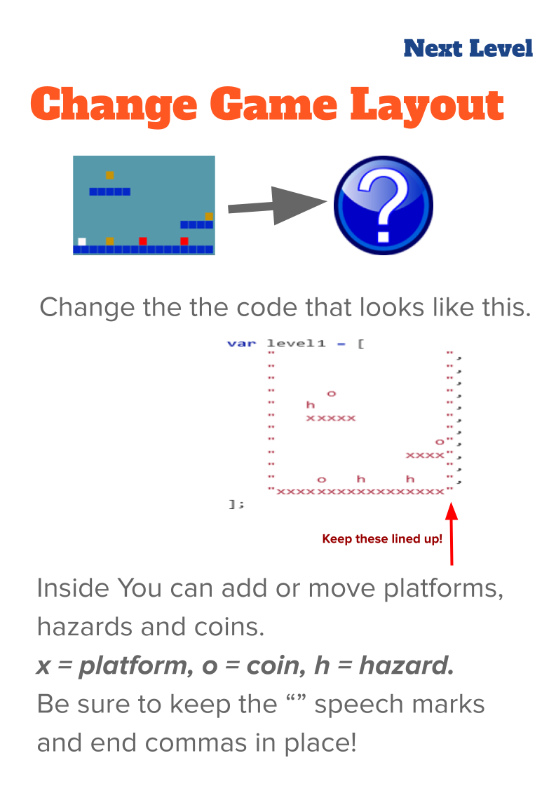 4.x - Example of a Quick start card
The templated game was structured to allow changes in code which were relatively easy to perform but which resulted in potentially large changes in game behaviour, appearance and difficulty. This created a large diversity in the games created by different pairs (adult-child dyads) despite the small scale of the code changes involved. Thus, while I created these resources and the corresponding code structures to facilitate a quick start, the diversity of experience kept some participants extended periods of time.
These observations build on the description of the game template in the last chapter.
Variable editing for movement: Participants needed to change the code to allow effective player movement. This thus forced all participants to alter at least one of the key variables that were highlighted at the very start of the game code. Following this first required change however behaviour varied greatly. While some participants engaged with extensive experimentation to find a player movement feel that seemed just right, others, mostly adults or younger participants, were much less concerned with this aspect of game play, despite frustrating player movement.
Level design and prototyping: The starting game template included a minimal amount of platforms, hazards to avoid and golden blocks to collect. Many participants spent significant time and effort on level design both in the initial stage and in subsequent sessions, undertaking many iterations of changes to the level design. As explored in the vignette in the previous chapter, Toby and several others designed to make the game challenging but still technically possible. In contrast, two participants played with the convention of the game by removing all hazards and filling the screen with rewards/coins.
Use of pixel art to seed narrative and art creativity: One activity that all participants spent some time on was to replace the coloured block of the starting template with pixel art sprites created using the Piskel tool. Participant spent a widely different length of time creating these graphics. Some took a long time to master the process of using the editing tool. Others struggled with the process of exporting the images to the code editor. Others were relatively rapid in creation but returned to alter their creations. As they had been guided to make a game on a broadly environmental theme, participants often redesigned sprites to games involving animals. The following image shows a whale as a player character and plastic bottles.


Observations on design behaviours encouraged through use of game template
While the simple changes to the game dynamics and patterns embedded in the starting template were motivation and engagement, some participants soon began to ask how to make additions to the game. A common request was to add a moving enemy to the game. There was a great divergence in the amount of time learners took to want to progress beyond making embedded changes to adding new game design patterns. One parent Molly did not progress beyond this point despite engaging in phase three and phase four, focusing on graphical design and developing narratives. In the feedback session she commented that she was happy to reinforce her existing learning.
At this quick start stage, participants required knowledge of very few coding concepts. It useful to compare this to a typical process of learning to code in a text language from first principles where the learner is met with a great many new concepts in the process of being guided to construct even the most basic of programs. Thus, while some basic alterations are being made, this stage of learning design aligns most closely with the Use stage of the UMC model (see lit review/ glossary) (Lee et al., 2011).
Instead, analysis of the video data of participants reveals a large number of broader digital literacy skills involved in certain processes. For example, the processes of replacing a block image with a bespoke pixel sprite comprised: file downloading; file migration using the browser and file manager; browser tab navigation; graphics tool use in Piskel (a simplified Photoshop including - crop, fill and export tools); copying and paste text code; and selecting more than one lines of text code with mouse or keyboard shortcuts. Undertaking the full process involved learning a complex chain of these individual actions.
Some participants became remarkably adept at this, thus transforming this chain of actions into a fluid operation. Learners who had mastered the skills were asked by others for help. The rapid adoption and transfer of these processes between community members indicated a high motivational factor for participants of incorporating self-created graphical elements, a topic which is also addressed in the following section.

Emerging processes and use of tools
The chapter has until now discussed some of the uses of drama processes and a bespoke toolset which as an educator I brought to the learning design. While these tools and processes emerged in response to articulated and inferred learner need, in contract, the processes explored in the following section emerged more directly from input from the participants involved.

Emerging use of narratives and graphics which draw on home funds of knowledge
The literature review outlined the potential of home interests as funds of knowledge, especially informal learning. This learning design provided participants with different ways to input and explore their home interests in the narrative and graphical elements of their created games. For example, the choice of game characters allowed the expression of identity. Other designed elements for example audio and graphical effects or written messages added to the overall aesthetic or polish of the game.
Video evidence indicated that conflicts between learner expectations and their technical abilities are helped by the use of the starting template. The constraints of provided game elements and implied narrative structure of the template accelerated the initial creative process.
One pair Clive and Pearl, the grandparents of Toby, included a narrative message at the start of their game. This process surfaced the expertise of the family as beekeepers, sparking interesting conversations with other participants.
var starttext = "This is a game which pits a honey bee against a swarm of Asian hornets, which are alien invaders attacking bee hives in the UK and which beekeepers are trying to stop spreading here. Try to guide the bee to collect all the flowers without being caught by the hornets.
Use the arrow keys to move the bee. Press return to START.";
In another example, Mark and Ed designed a game around the character of a train driver that needed to collect coal. In subsequent post course interview Mark describes the impact of the child feeling like they could bring their own identity and interest into the project. “I know just your eyes lit up when you realised you could expand your interests into gaming.” See Appendix 4.x (Mark and Ed working with home interests)
Other participants expressed pride over their graphical creations. In this excerpt parent Molly has spent time creating a pixel art representation of an alien. The full exchange (see appendix 4.x) sees Molly cultivating a sense of ownership over the graphical element that she has created. There is also the development of a growing sense of competency in this area of asset design. She notes she is an “expert pixel”.
Molly: We’re finished. Right what’s next? Now I’m an expert pixel? Now I have to figure out how to get it in there, don’t I? Without losing it. I’ll be very upset.
Sonia: Have you saved it?
Molly: No I’ve not saved it.
Sonia: Save there. (points to relevant button on screen)
The growing mastery of this area also seems to help drive motivation to complete the next challenge. The sense of ownership spurs the technical process of saving projects. Her pride in her work and concern surrounding losing it provokes a fellow parent to show her how to save her work.

Summary: Home Funds and RQs
This research supports finding of other research which highlight value of incorporating home interests in games, coding and media projects (Papert, 1980a; Resnick, 2012). It also aligns with PBL literature which advocates the personalisation of projects and the value of exploring concepts using home funds of knowledge (Moje et al., 2001)
This research indicates that in particular, allowing participants to incorporate home interests can be highly motivating in early stages of the design process. It can also sustain the coding activity later in the process encouraging participants to overcome problems in order to share the personalised object created.
In addition, the tacit knowledge of children as game players gives them access to varied affordances in the process of feeding back.
There is also evidence here that frictions involved in dealing with participant expectations of the genre and professionalism of the game they will create, are helped by the use of a templated game. Both in terms of the technical platform and the implied narrative and creative frame which scaffolds the initial creative process. This supports existing research on the value of constraints in facilitating rapid creative improvisation in the areas of music and drama. The domains of programming, game jams and hackathons also use constraints in a similar way (Gabler et al., 2005). HOW TO EXTEND?

Playtesting

As explored in the literature review and previous chapter, playtesting offers rich and varied learning opportunities which encourages community-building behaviour.

Playtesting as a social process
Participants, particularly older ones, used playtesting as a way of showing support for fellow game makers. Example behaviours included: praising graphical content; making links with home interests of participants through questioning; and building rapport. Molly in particular used playtesting to show her appreciation of the graphical work of others especially in the creation of cute animal characters. In response to one game which featured an image of a dog, other participants asked: Do you like dogs? Do you have a dog at home?
Playtesting and embodied participation in the games of others
Some children added additional playful elements to playtesting. Because these interactions were mobile between works is it hard to extract audio and transcribe their speech. However, it is possible to communicate the characteristics of this play via a description of a typical encounter and the gestures of participants.
WATCH MORE CLOSELY AND TRANSCRIBE GESTURES
Play is initiated by calling across the room as an invitation to play, or as a provocation. When playtesting is underway it is normally undertaken with two or three participants standing around the computer rather than being seated. The core of those involved take turns to play the game, exclaiming frustration or triumph at completing levels or failing. Failure may be extremely performative with a rapid pulling away from the screen and keyboard. This may be followed with a battle to wrestle control of the keyboard to play the game next. This may involve playful pushing, and wrestling of hands and arms and vocalisations. While this play is happening it may attract other participants who remain on outskirts of the activity looking on able to watch what is happening on the screen and respond non-verbally with smiles or laughs.
These changes to the form and function of playtesting by young participants is another example of expression of agency by participants that widens the scope of possibility of actions.
Community concepts and norming behaviour emerging during playtesting
The elements of variables controlling player movement and the ability to place hazards in the layout of the platform game were initial changes that all participants made to the original template but the end results greatly varied in terms of the challenge of the games. Discussions on game challenge, specifically comments about how ‘hard’ participant games were the most common forms of interaction during playtesting.
Through this informal feedback participants sought to influence peers to modify the playability and challenge built in to games to increase the enjoyment of peer players. For example, parent Molly had been focused mostly on completing asset design and this had created a very frustrating game experience in terms of the player’s movement. Just before this extract, as a facilitator, I shared feedback about using quite indirect technical language when giving feedback (See appendix 4.x).
Bertie: That looks nice (referring to the graphical look of the game)

Molly invites Bertie to play as she can't progress due to the difficult game controls.

Bertie: It jumps super high but so slow.
Pause
Molly: He has to go slow because he's an astronaut, you see.
Bertie: It's hard.
(Bertie leaves.)
Molly: (to peer parent with proud tone.) It's hard. Wow.

(Ed comes to play the game)
Ed: How much jump speed to you have?
Ed: Your jump speed is massive.
Molly initially misconstrues feedback from Bertie that her game is hard as a positive thing. A variety of comments nudge Molly to change her game to align with an emerging community norm of what a sensible jump behaviour should be. Feedback from Mick attempts to bridge a technical and conversational approach. Feedback from Bertie is direct about his player experience as a player. Ed gives a more technical explanation from involving the naming of the variable jump speed.
Other children come and play the game but only for less than a minute before leaving. Towards the end of the playtesting process, as one child leaves, Molly comments “It’s so frustrating.” This suggests an evolving understanding that her game is frustrating to players rather than pleasantly challenging.
The less directive norming behaviours here mirror observations seen in the work of Rogoff and colleagues(Rogoff, 2003) on learning in community settings. There is an apparent tension in play here between encouraging individual agency of expression within the game and an evolving community tendency to norm peoples games to be more playable, specifically that player movement should conform to wider expectations.
To better understand this process it is relevant to locate the source of these wider expectations and to evaluate their utility here. This is attempted in the discussion section of the chapter.
What we can draw from the data at this stage is that playtesing provides many leverage points to facilitate learner agency and discuss the limits of designs. In addition, playtesting is a process that allows participants to demonstrate informed criticality as a player and guide the creations of peers via gameplay feedback.

Flexible divisions of labour
Analysis of video data uncovered the flexible ways in which the participants divided up the process of game making. While these processes were emergent in that they were not in by the facilitator, they show traces of home collaboration practices. For example, Suzanna and Olivia alternated between use of keyboard and mouse to give the child hands on experience when possible. In interview data the parent note “I resist the urge to fix things immediately when she struggles.” The parent taking the driving seat to overcome code blockages then allowed the child to input their design choices when more complicated work is complete.
Toby and Dan’s pair process of accessing professional documentation also illustrated an aspect of their family learning culture. The pair’s process is more guided and focused than many other participants. In several interchanges the father starts as a facilitator taking a lead from the direction of the child. As the child reaches the limits of their ability he begins to be more directive, by asking leading questions and testing existing knowledge. Finally, in order to complete the programming or research tasks beyond of the child’s knowledge, the father is more direct in instruction, directing the research and proposing a coding solution for their new game design pattern.
This approach appears to be influenced by Dan’s experience as a software engineer and volunteer at Coder Dojo (Glossary). Interview extracts (included as appendices) show a direction to support the novices direction as a facilitator where possible.
I try never to touch the keyboard of who's there. If they are stuck on something I always tell them what to do. Even if it's then taken me five minutes to explain what a semicolon is. And point. It's that key. Because it was just, I could do it so effortlessly. I think I'm sure I put people off very quickly by "Dave did something really quickly. I don't know what it was.".
This extract from interview data indicates a priority to support the learner to develop independently but to still be very present in the support process.
Leveraging the possibilities of emerging divisions of labour: While the context of the participants as families involved in home education makes any general claims difficult, these observations support exist in other research in this domain. For example, research shows that children have the potential to help parents as technology brokers (Correa et al., 2015). In joint technology work parents can fulfil several,reciprocal roles including, collaborator, resource provider, learner, non-technical consultant and emotional support (Barron et al., 2009).
Thus, in response to the creative support that parents and siblings provide, facilitators should design learning environments to facilitate these possibilities. The work of Roque on FCL provided guidance for helpers in the process to support parents to value and feel confident these roles (Roque et al., 2016) in a way which mirrors the use of helpers this phase of my study.

Discussion

Flexible design practices
As explored in the literature review, design stages as a conceptual design tool is common in CS education, e.g. Resnick’s creative learning spiral (Resnick, 2007:2). While I did not ask learners to follow prescribed design stages, in data analysis I created a coding theme based on a design cycle framework: Ask / Imagine, Plan, Create, Test, Improve, Share. When coding I observered that naturalistic practice rarely matched the progression of the design cycle. The stages were instead fragmented and sometimes happened in parallel. In many interactions I observed improvisational approaches which incorporated ideation, planning, implementation and testing in space of a minute or so. If I had encouraged participants to follow prescribed design stages this may have restricted this flexibility in practice. This concern is echoed in research which critiques a similar, staged approach to creative writing in primary education using a writing cycle approach. (Kuby, 2016)
In a closer review of key literature claims of the value for participants of following design cycles are implied but not supported. Instead stages are proposed as a tool to “discusses strategies for designing new technologies” (Resnick, 2007:2). the following writing discusses the value of flexible approach to design processes observed in my research.

The potential of emergent “non-productive” activities
Much time in sessions was spent on activities that did not fit neatly into an accepted design stage, for example: opening software tools; navigating to correct locations; and finding past assets. These processes often involved significant effort and collaboration between participants. For example, the migrating of assets between authoring tools, converting to correct formats, evaluating new tools, and finding previously created assets. These are practices that I am personally familiar with. I call them digital laundry or digital housekeeping. Things that at times can be low attention span. Faff time is even less productive switching on the computer and waiting for the internet to connect, waiting for a family member to finish their rushed lunch or navigating to the right location in creative software.

Skills to perform these activities were at often distributed between different family members. For some adult re-enforcing their identities as project managers, and for young participants forming identities as digital specialists. I noted in analysis of data that along with frustration there are also moments of creativity, and there are bonding moments which appear to be helped by this activity which is at times quite unfocused but also shared. In retrospect, many of the social missions explored above encouraged activity outside of established design stages. For example the lively discussion about game playing in response to the mission to find out the favourite games of 3 other people.
The process of swapping graphical assets used a shared Piskel gallery and games area which served to keep individuals informed in directly of progress being made, and to spark curiosity in the creations of others.
In addtion, I observed that navigating these essential but non-creative tasks in a collaborative and playful way can reduce learner anxiety and help maintain a positive affect to the overall creative digital process. This observation is supported by an example in the next chapter available in appendix 5.x - an extract of which is included below.
Participant Dialogue | Participant Gestures & Activities
 | Nadine has just rapidly demonstrated how to bring a created graphical element into the game
Molly: How did you do that so quickly? I’ve got to like, carefully… | Molly makes hand gestures to show a sense of hesitant keyboard use)
 | A parent peer next to Molly laughs. Nadine, the child of Molly bounces up in place and smiles broadly.
In summary, it is of value to create spaces to leverage the potential of these in-between moments for participants. This a concept is developed later in this discussion.

Supporting Digital Jamming
Flexible design practices are often present in recorded data. Younger participants in particular developed impressively fluid practice demonstrating extremely rapids shifts between code editing, game testing, authoring assets in online tools and migrating files often while talking with peers. Older participants also showed rapid, responsive creativity. Clive quickly incorporated a boost to player health after a level after being given feedback during playtesting. In exploring sound making software Ed and Mark start a process of tinkering and messing about with the capability of the tools which spurs creativity. The joint jamming created two different soundtracks. This sparks a new proposal to incorporate different soundtracks for different levels. Pairs often adopted a similar spirit of improvisaion. For example parent Dan makes a suggestion - “Use paper to design?” - to which Toby replies “I’m just going with it.”
These observations of the value of flexible design processes, invite discssion on how best to conceptualise and support these flexible approaches. Game Jams are accelerated events encouraging creative collaboration and innovation. While the event’s premise is to promote collaboration, these events are inconsistent in their support and scaffolding of collaborative approaches (Goddard et al., 2014).
Other relevant perspectives include rhizomatic design approaches (de Freitas, 2012). Research exists on the promise of rhizomatic approaches design thinking in creative educational programmes (Biffi et al., 2017). However researcher identify significant competencies required including to “identify and synthesize the body of technical and even complex knowledge into a feasible structure” (Biffi et al., 2017:972), which are not well-aligned with the age group of this context.
Instead, I propose that the tools, process and the community in this study mutually encourage an improvisational approach often referred to as jamming. Jamming, a term common in music and theatre, describes responsive, improvised, rapid and fluid responses to collaborators ideas and audience reactions (Sawyer, 2003; Pinheiro, 2011).
THIS SPACE LEFT INTENTIONALLY BLANk MORE SYNTHESIS HERE

Discussion on authenticity
Returning to the work of drama processes, Heathcote (Heathcote and Bolton, 1994) warns against asking participants to genuinely make items in the processes explored. To do so, she argues, would expose their inexpertness in the cold light of day.
“if they are makers of things (for example, shoes, ballgowns, or aircraft) they must never (within the fiction, that is) be asked to create the actual objects. If they had to do this their in expertness would become immediately apparent.”(Heathcote and Bolton, 1994:18)
Authentic tools in settings where students may find their novice skills lacking can negatively impact on experiences of self-efficacy and thus agency. While this is clearly the case in factory-based drama proceses, the value of digital tools allows students to to work with more authentic practices.
In addition, an inspirational aspect of lifting the lid on previously unknown technology was reflected in a conversation among adult participants. They communicated a sense of awe of how much code must be involved in a professional game based on the relative complexity of the code of their simple game.
While the last chapter addressed authenticity of tools and processes in general terms this chapter has explored the impact on learners. For example, the design of the starting template shielded learners from much of the complexity of the underlying web-technology and provided affordances via embodied elements that facilitated learner agency via expression of home interests, play with dynamics and game layout. The partially working environment and immediate feedback this allowed also gave rapid access access to varied forms of face to face community activity including varied forms of playtesting and social interaction and ways to access help from peers and facilitators.
These observations support existing research on computing projects in the work of Papert (1980b) on Mircoworlds and subsequent research on programming tools in the constructionist tradition (Kafai and Resnick, 1996; Kafai and Burke, 2014). In this study, in contrast to the specially created tools of Scratch and Logo, the protected Microworld is built as a shield area within a more genuine ecology of authentic tool use and practices.
Authenticity in project approaches can profitably be applied to tools, processes and project goals (Hung et al., 2006). Authenticity in goal here is clear. Participants make a real digital game. The authentic goal of making a game allowed participants to draw on tacit knowledge and navigate within implicit bounds reducing the need for intrusive instruction which might negatively effect feelings of agency. As explored in the previous chapter and in the results of this chapter, the authenticity of the tools and processes involved are more complex.
In summary, while the use of authentic tools and processes, while challenging for novices, can be facilitated by careful alignment of key design principles and other pedagogies. For example, while the complexity of authentic text code languages and authentic developer focused documentation can be intimidating, the following section explores the potential for drama processes to address learner anxiety in this domain.

Agency and emerging spaces for community activity

Positive affective space within a drama process
The work in this research around designing and coding in role and creating a playful context and language mirrors work done in learning languages to reduce learner anxiety by leveraging the potential for drama processes to create positive “affective spaces” (Stinson and Freebody, 2006; Piazzoli, 2011). The drama process can be viewed as magic circle (Stenros, 2012; Whitton, 2018). A magic circle is a concept which transmits the idea that game players enter a loosely bounded play space where they accept arbitrary play rules and enter a social contact to adopt a playful attitude.
The experience of myself and participants being more comfortable performing some of the activities in role is facilitated by contracted together into a playful agreement where risk of perceived failure is reduced. In my journal notes, I observed, that when listing boundaries to activities within role, it felt similar to outlining the rules of a game rather that constricting their behaviour. Thus, I felt more relaxed restricting choice in role via the proxy of a playful encounter compared to my previously I concerns surrounding participants feeling overly controlled.
In addition, I believe part of my hesitancy in shifting activity from participant-led game making to reflection, or accessing documentation, stemmed from worrying that the learners would also find this shift in objective, from the organically developing design and play testing activity system to an externally imposed system of reflecting on progress, would be jarring, potentially disorientating and reduce learner engagement and positive affect towards the overall process. In other words, provoking a feeling that the fun’s over, it’s back to school. I propose that the drama fiction eases friction between competing activity system objectives.

Extending the metaphor - anchoring in sheltered harbours
This chapter has discussed affordences of a bespoke and mutually designed learning exeriences and their impact on learner agency. At times, Sannino’s metaphor of a kedging anchor thrown by participants to pull themselves out of a conflict or blockage in their process has been used. The metaphor is useful to explain the active process of participants seekig to resolve conflicts and problems in their creative processes. However, much research employing this metaphor is often used in less-structured workplace settings. As such, the designed nature of the environment is less relevant. This section proposes an expansion of the metaphor to encompass concerns of a more structured learning design.
In the original metaphor the casting of the anchor is random, experimental. It is unsure if the anchor will catch on anything under the surface. However, in this design, participants aim for affordances as visible anchor points. In the design above such anchor points include: regular play-testing; the use of documentation; and highlighed variables and level structure in the quick start stage.
To aid learners agency, designers notice existing paths of participants and add explicit anchor points and make them visible to learners. The process is on-going and mutual. Additionally, this work happens in an facilitated environment. Design decisions server to clarify common problems areas, thus making the water clearer to better see anchor points. The job of the designer is in part to identify the causes of turbulence and thus create support in a sheltered space of a harbour.
Many design decisions were made to create a supported, simplified coding environment. Relevant examples from the previous chapter include: using an online code playground; skirting use of specialist terminology; hiding away un-needed complexity in the code template.
While it is important to acknowledge the danger that such support may make learners run into trouble if coding other projects outside of this supported space, the use of authentic code language makes this less of an issues than with specialised coding environments aimed at novices (Hagge, 2018). Thus to make one addition to the metaphor this design is like a sea-harbour, tools like Scratch are like a swimming pool.

Implications in conceptualisations of forms of agency
Previous chapters explored varied understandings of agency. To here is a potential tension between instrumental agency and transformative agency. In designing out conflicts the facilitator may reduce the capacity for participants to profitably address them, both as individuals pair or collectively as a group. There is a balance here for the facilitator to take an appropriate position on. The following conclusion explores these tensions in more depth.

Conclusion Nurturing agency by creating space for emergent practices
THIS SECTION IS STILL UNDER DEVELOPMENT
This section continues to explore tensions surrounding support learner agency, useful conceptions of agency, and starts to explore recommendations for researchers and educators working in this area. As previously explored, varied conceptions of agency exist including: instrumental, authorial and transformative agency (Matusov et al., 2016). (See methodology chapter). As a learning designer, design decisions to create a sheltered harbour, increase the instrumental agency of learners allowing them to experience a feeling of control over their creative process.
Adopting analysis which aligns authorial agency and transformative agency, there is a potential tension between instrumental agency and transformative agency. A design which minimises possible conflicts also reduces the potential for participants to solve them both individually and collective responses.
Thus, I propose that key areas of the learning design should be more open in structured to encourage the emergence of participant responses and novel practices. The concepts of affective space and magic circle previously explored in the context of drama process as a way to encourage participants to improvise from a starting structure are of value to provide guidance to practitioners in the domain of informal digital design.
A different but relevant challenge is the difficulty of structuring resources in a way which can support the diversity of the directions in which participant want to progress their design. Drawing from authentic resources can be chaotic and create problematic errors.
Participants may also lack the concepts and technical language needed to find external support materials easily. Some of these challenges are potentially addressed through the combination of possibilities of the starting and a selection of curated code examples. The next chapter explores the use of a collection of game design patterns to help address these issues.

Aitken, V. (2013) ‘Dorothy Heathcote’s Mantle of the expert approach to teaching and learning: A brief introduction.’ Connecting curriculum linking learning pp. 34–56.
Bakioglu, B. S. (2008) ‘Spectacular Interventions of Second Life: Goon Culture, Griefing, and Disruption in Virtual Spaces.’ Journal For Virtual Worlds Research, 1(3).
Barron, B., Martin, C. K., Takeuchi, L. and Fithian, R. (2009) ‘Parents as Learning Partners in the Development of Technological Fluency.’ International Journal of Learning and Media, 1(2) pp. 55–77.
Bartle, R. (n.d.) ‘HEARTS, CLUBS, DIAMONDS, SPADES: PLAYERS WHO SUIT MUDS’ p. 27.
Biffi, A., Bissola, R. and Imperatori, B. (2017) ‘Chasing innovation: a pilot case study of a rhizomatic design thinking education program.’ Education + Training, 59(9) pp. 957–977.
Correa, T., Straubhaar, J. D., Chen, W. and Spence, J. (2015) ‘Brokering new technologies: The role of children in their parents’ usage of the internet.’ New Media & Society, 17(4) pp. 483–500.
de Freitas, E. (2012) ‘The Classroom as Rhizome: New Strategies for Diagramming Knotted Interactions.’ Qualitative Inquiry, 18(7) pp. 557–570.
Gabler, K., Gray, K., Shodhan, S. and Kucic, M. (2005) ‘How to prototype a game in under 7 days.’ Gamasutra, October, 26.
Goddard, W., Byrne, R. and Mueller, F. ‘Floyd’ (2014) ‘Playful Game Jams: Guidelines for Designed Outcomes.’ In. ACM Press, pp. 1–10.
Hagge, J. (2018) ‘Coding to Create: A Subtext of Decisions as Early Adolescents Design Digital Media.’ Technology, Knowledge and Learning, 23(2) pp. 247–271.
Heathcote, D. and Bolton, G. (1994) Drama for Learning: Dorothy Heathcote’s Mantle of the Expert Approach to Education. Dimensions of Drama Series. ERIC.
Hung, D., Tan, S. C. and Koh, T. S. (2006) ‘Engaged Learning: Making Learning an Authentic Experience.’ In Hung, D. and Khine, M. S. (eds) Engaged Learning with Emerging Technologies. Berlin/Heidelberg: Springer-Verlag, pp. 29–48.
Kafai, Y. B. and Resnick, M. (1996) Constructionism in Practice: Designing, Thinking, and Learning in A Digital World. 1 edition, Mahwah, N.J: Routledge.
Kafai, Y. and Burke, Q. (2014) ‘Mindstorms 2.0 Children, Programming, and Computational Participation.’ In.
Kuby, C. R. (2016) ‘Rhizomatic Possibilities for Writing Processes: Fluid Structures and Components.’ In Reclaiming Early Childhood Literacies. Routledge.
Lee, I., Martin, F., Denner, J., Coulter, B., Allan, W., Erickson, J., Malyn-Smith, J. and Werner, L. (2011) ‘Computational thinking for youth in practice.’ ACM Inroads, 2(1) pp. 32–37.
Matusov, E., von Duyke, K. and Kayumova, S. (2016) ‘Mapping Concepts of Agency in Educational Contexts.’ Integrative Psychological and Behavioral Science, 50(3) pp. 420–446.
Moje, E. B., Collazo, T., Carrillo, R. and Marx, R. W. (2001) ‘“Maestro, what is ‘quality’?”: Language, literacy, and discourse in project-based science.’ Journal of Research in Science Teaching, 38(4) pp. 469–498.
O’Neill, C. and Lambert, A. (1982) Drama Structures: A Practical Handbook for Teachers. Nelson Thornes.
Papert, S. (1980a) Mindstorms: children, computers, and powerful ideas. New York: Basic Books.
Papert, S. (1980b) Mindstorms: children, computers, and powerful ideas. 2nd ed, New York: Basic Books.
Piazzoli, E. (2011) ‘Process drama: the use of affective space to reduce language anxiety in the additional language learning classroom.’ Research in Drama Education: The Journal of Applied Theatre and Performance. Routledge, 16(4) pp. 557–573.
Pinheiro, R. (2011) ‘The creative process in the context of jazz jam sessions.’ Journal of Music and Dance, 1(1) pp. 1–5.
Resnick, M. (2007) ‘All I really need to know (about creative thinking) I learned (by studying how children learn) in kindergarten.’ In Proceedings of the 6th ACM SIGCHI conference on Creativity & cognition. ACM, pp. 1–6.
Resnick, M. (2012) ‘Mother’s Day, Warrior Cats, and Digital Fluency: Stories from the Scratch Online Community.’ In Proceedings of the Constructionism 2012 conference. Athens, Greece.
Rogoff, B. (2003) The cultural nature of human development. Oxford [UK] ;a New York: Oxford University Press.
Roque, R., Lin, K. and Liuzzi, R. (2016) ‘“I’m Not Just a Mom”: Parents Developing Multiple Roles in Creative Computing.’ In Conference: International Conference of the Learning Sciences.
Sannino, A. (2015) ‘The principle of double stimulation: A path to volitional action.’ Learning, Culture and Social Interaction, 6, September, pp. 1–15.
Sawyer, R. K. (2003) Group creativity: Music, theater, collaboration. Mahwah, NJ, US: Lawrence Erlbaum Associates Publishers (Group creativity: Music, theater, collaboration), pp. ix, 214.
Stenros, J. (2012) ‘In defence of a magic circle: The social and mental boundaries of play.’ In Proceedings of.
Stinson, M. and Freebody, K. (2006) ‘The Dol Project: The Contributions of Process Drama to Improved Results in English Oral Communication.’ Youth Theatre Journal. Routledge, 20(1) pp. 27–41.
Whitton, N. (2018) ‘Playful learning: tools, techniques, and tactics.’ Research in Learning Technology, 26, May.

